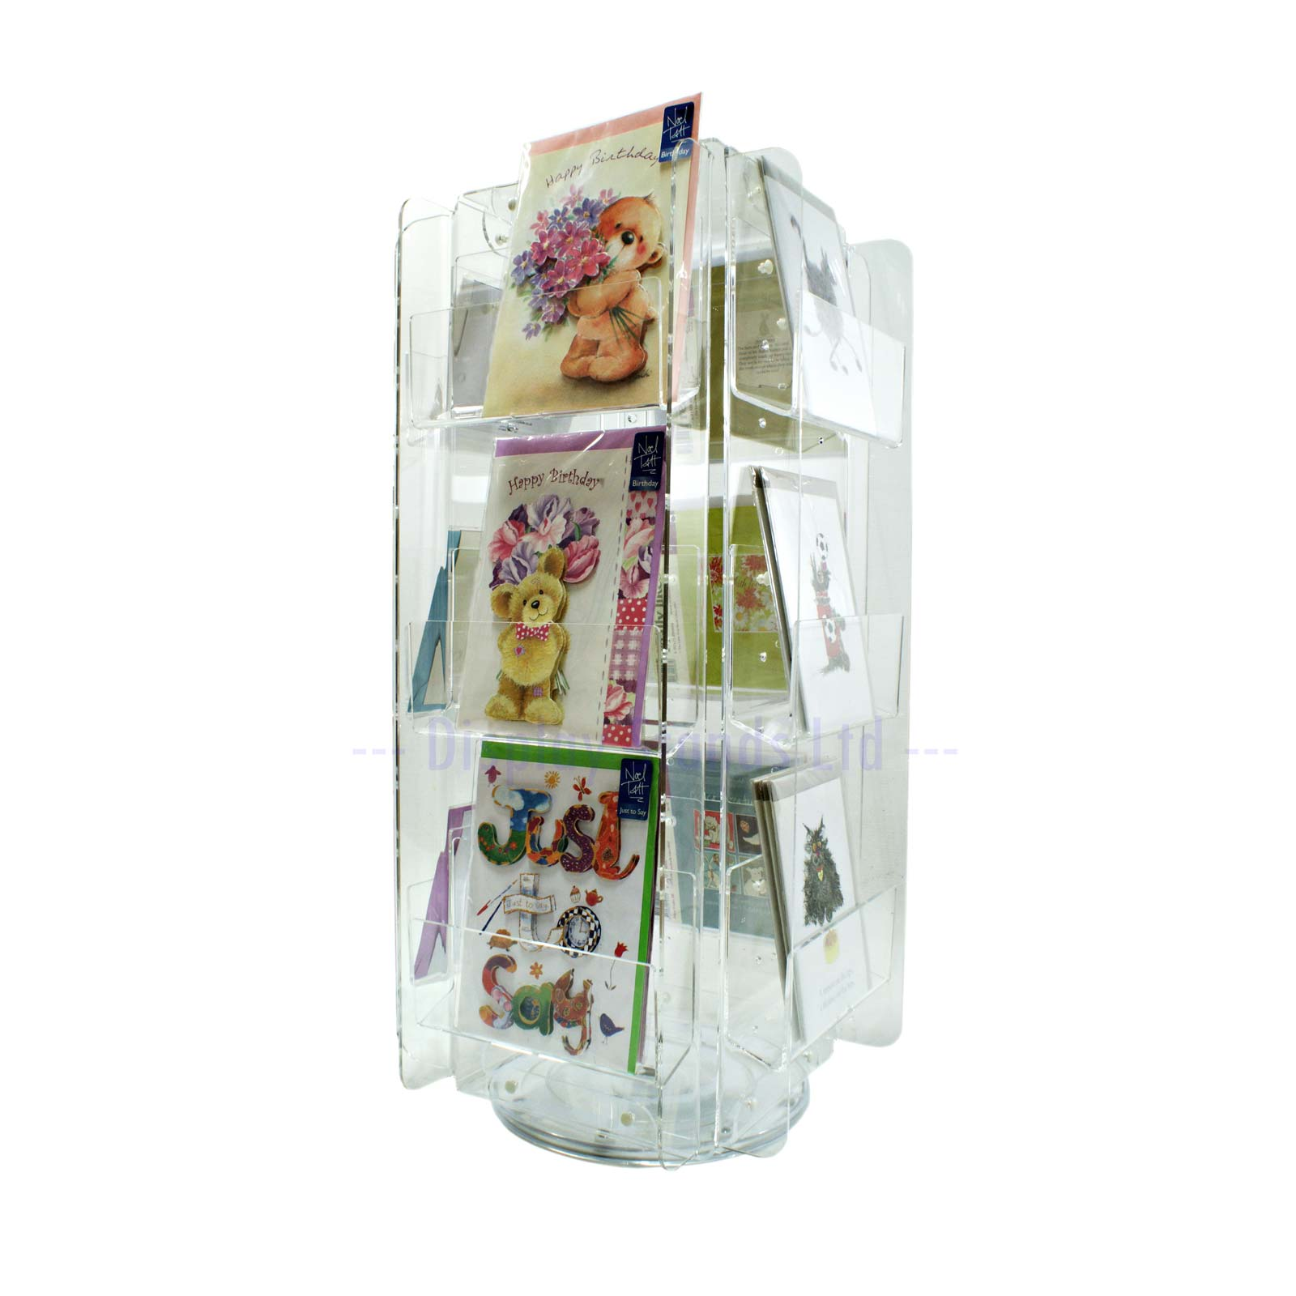

DS47 Assembly Instructions

Ideal display for Greeting card retailers, wholesalers, gift shops and visitor attractions.

* 12 clear acrylic pockets
* Fits 5" x 5", 5" x 7", 6" x 4", 6" x 6" & 7" x 7" Cards Portrait & Landscape.
* Adjustable pockets
* UK Designed & Manufactured
* No overlap
* Lazy susan bearing base (supplied & fitted)
* Full front facing display
* Robust build
* Clear acrylic frame
* Easy to assemble
* Small footprint
* Rotating
* Supplied flat packed
* 11 pocket placement positions
* Plastic rivets (supplied) for assembly and pocket positioning

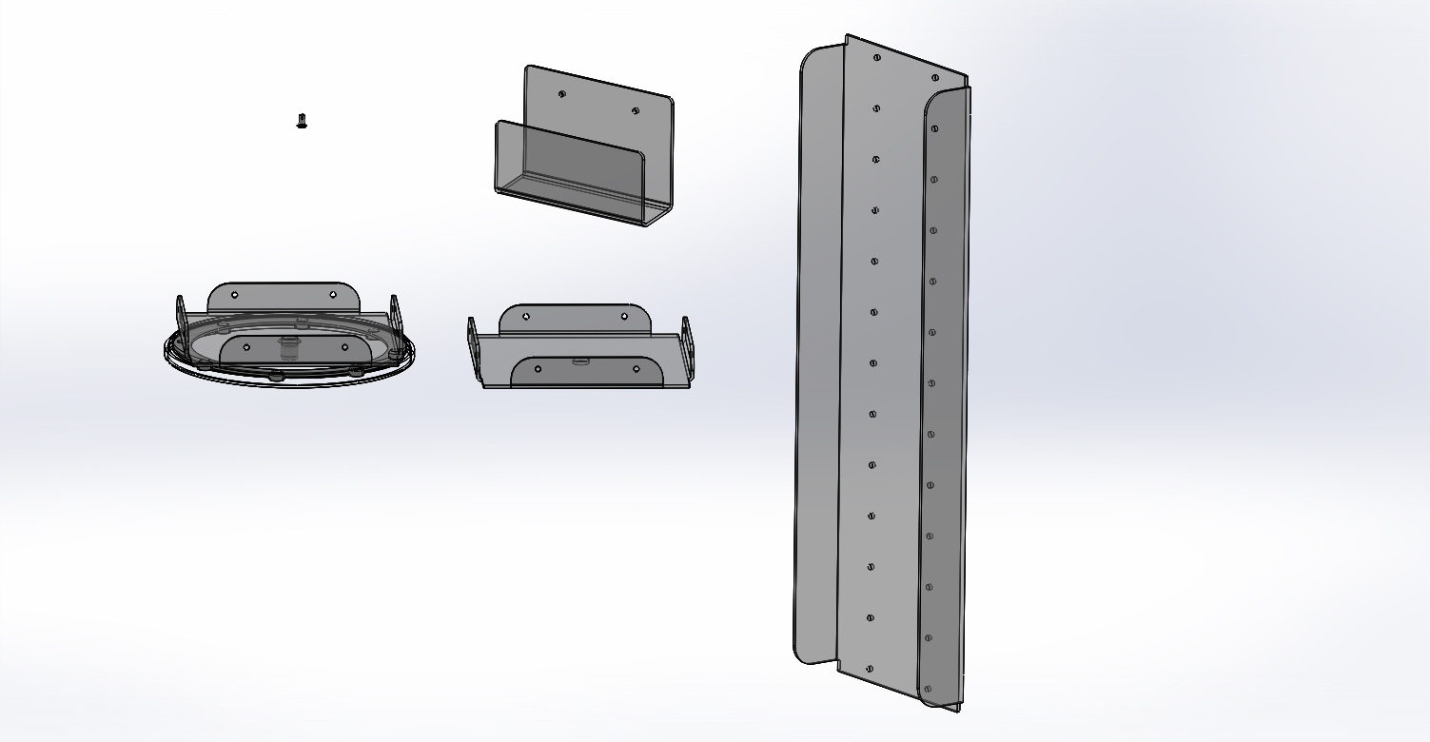

1. Rivet pins in white plastic. Qty 24.

2. Pockets in clear plastic. Qty 12

3. Rotary base in clear plastic. Qty 1

4. Top cap in clear plastic. Qty 1

5. Panels in clear plastic. Qty 4

3. Rotary base

5. Panels

4. Top cap

2. Pockets

1. Rivet pins

DS47 - Components

Remove all coloured protection film from the plastic sheet before assembly. This will be on both sides of the sheet.

|  |  |  |  |
| --- | --- | --- | --- |
| Open position  Rivet pin.JPG | **2)** Start with the Rotary base and one panel. Align the bottom two holes on the panel with two holes on one of the flanges of the base unit.  With the rivet in the open position, push a rivets through the holes of the panel and through the aligned flange holes of the base.  Push the rivet until it is in the closed and locked position | Assem2.JPG | |
| **1**) The rivet pin can be open or closed. |  |
| Assem1.JPG  Closed position |
| Assem5.JPG  **3)** Continue to add all 4 panels in the same manner and then add the top cap using the top two holes of each panel. | | Assem3.JPG  Un-locked | Assem4.JPG  locked |
| **4)** All that remains is to assemble the pockets to the frame using the remaining rivets, 2 per pocket.  There are a series of holes on each panel. Choose two horizontal holes and use the rivets in the same way you used them to assemble the main unit.  You should be able to assemble 3 pockets per panel. |  | Assem4.JPG | Assem11.JPG |